Theme/Title of the Unit:

El mundo laboral en España

General Information:

- Targeted learners: L2 learners of Spanish (non-heritage)-Higher education
- Performance range: Novice Low/Mid
- Duration: 2 weeks, 3 days a week, 50 minutes per class.
- Methodological approach: Flipped-model classroom
- Theme: Work in Spain
- Essential question: who does what jobs in Spain?

Key Social Justice and Language Goal:
Learners will be able to describe, analyze and discuss the job market to reflect on the disparities and inequalities among different members of Spain and of their own communities.

Supporting Goals:
In order to accomplish this goal, learners will:
- Identify the main parts of a job ad from the Spanish-speaking world.
- Discuss specific requirements/qualifications of some jobs.
- Report and analyze the changes of some working sectors from a chart.
- Describe the duties of specific jobs.
- Reflect on the jobs and who performs them in their own culture and in the target culture.
- Interview guest speakers from the Hispanic community about their jobs and the different members of their teams.
- Create a presentation about the demographic population that performs a specific job in a specific Spanish-speaking country.

World Readiness Standards:  1. Communications: Interpersonal Communication: Learners will interact and negotiate meaning regarding the topic of work and its demographics in Spanish speaking countries and their own.  2. Connections: Learners will engage with websites regarding job postings and demographics, which will allow them to expand their knowledge of other disciplines (such as the working world in Spanish speaking countries and its inequalities) while using the language to access and evaluate information and develop critical thinking.  3. Cultures: Learners will be able to investigate and reflect on different practices (who performs which job?), products (job postings), and perspectives (what are these practices and products telling us about the belief system of a given culture? Who holds the power and who does not?)  4. Comparisons: Learners will be able to reflect on the role of these practices, products, and perspectives in the target culture as well as their own cultures.  5. Communities: Through the communication with the Hispanic/Latinx local community, learners will be able to explore and interact with individuals that are part of the workforce. They will learn from other’s experiences and share their own. | Products, Practices and Perspectives:  - Products: Job advertisements, job postings, websites, news reports.  - Practices: Learners will be able to interpret and analyze graphics and news reports regarding who performs specific jobs in the target culture.  - Perspectives: Through the analysis of products and practices, learners will be able to reflect on the dynamics of power and the belief system of a given society as well as their own.

WEEK 1

DAY 1: Identify the main parts of a job ad from Spain.

Warming up-Prior Knowledge | Brain storming activity: Learners will discuss what it entails to be a student and whether they like it or not.
Task 1. Provide input (I) | Matching activity: In pairs, learners will match the professions with the place where the job is performed. Ex. Doctor-hospital
Task 2. Provide input (II) | Finding the correct answer: Learners in small groups will be given different job descriptions found in online websites such as infojobs.com. These descriptions will be missing the key part: the profession (from the vocabulary list provided in Task 1). Learners will have to read and identify the profession that best matches the description. Ex. Screenshot bellow (information taken from https://www.infojobs.net/pozuelo-de-alarcon/camarero-con-experiencia-aravaca-jornada-parcial-20h/of-i9822d0b6f24c119d7113e0e8a6b917?applicationOrigin=search-new&page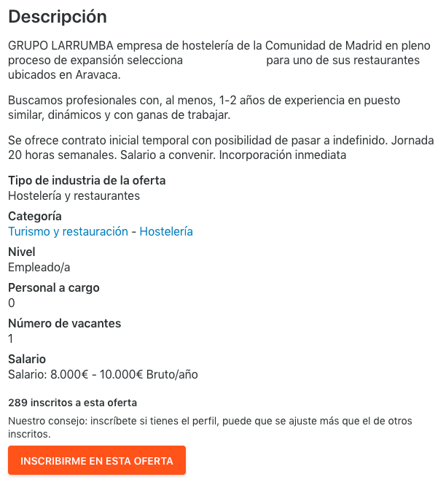=1&sortBy=PUBLICATION_DATE).
Task 3. Use of language (I) | Part I: In groups, learners will choose 3 professions (waiter, professor, professional athlete…) and will complete a job description table modeling the ones from task 2.  Categoría Nivel Personal a cargo Número de vacantes Salario  Part II: In groups formed by 1 different member of each group of part I, learners will have to decide the job other learners are describing.
Task 4. Use of language (II) | Learners will be divided in small groups to discuss what they are studying and what they want to be in the future and why. Then, they will share their partner’s answers with the class.
Closure / Cool down | Learners will be presented with some reflective questions that they will be able to discuss, after class, in a discussion forum. Ex. Are we free to choose the work we want? What external factors may impact our choice?
DAY 2: Discuss specific requirements/qualifications of some jobs.

Warming up-Prior Knowledge | Brain storming activity: Learners will discuss what some famous Hispanic people on screen do for a living. Ex. See example below   Ellen Ochoa à Ella es astronauta
Task 1. Provide input (I) | Matching activity: In pairs, learners will be provided with a list of qualifications (speak another language, being more than 6 feet tall, holding a BA/BS degree…) and will decide what a person needs to be qualified for a specific job. Ex. Un/a/e traductor/a/e necesita----hablar dos o más lenguas.
Task 2. Provide input (II) | For this activity, learners will be in small groups and each group will be assigned to find online 1 job posting (from Hispanic websites). They will have to write in a document the qualifications that are needed for each job in order of importance.
Task 3. Awareness-raising | Once the gather the information from task 2, they will have to respond to the questions: Are all the qualifications listed necessary? Which ones are or aren’t and why? Can you think of other qualifications that are not usually listed in job postings but might be important? Ex. See table below:  Nombre del trabajo ¿Qué necesitas para estar cualificado?
Task 4. Use of language | Learners will be divided in small groups and will be asked to think of a dream job. Then, modeling the language of the job postings they have been exposed to in days 1 and 2, they will write their own job posting including the important qualifications.
Closure / Cool down. | Learners will be presented with some reflective questions that will serve as a link to the following class discussion. Ex. what can a person do to be ‘qualified’ for a job? Can every one access the higher paying jobs in our societies? Why or why not?
DAY 3: Report and analyze the changes of some working sectors from a chart.

Warming up-Prior Knowledge | Brain storming activity: Looking at the graphic in the screen, learners will discuss what they observe (what jobs are the most employable in Spain, how the numbers have evolved since 2008, etc). Ex. See graphic below https://www.elblogsalmon.com/mundo-laboral/en-que-sectores-hay-mas-empleo-en-espana  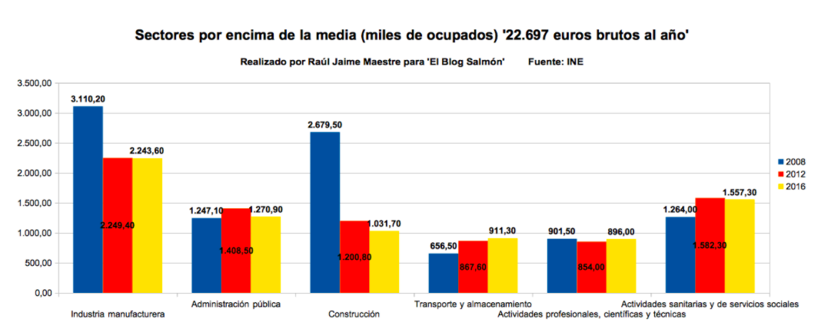  Hay menos personas que trabajan en la industria manufacturera en España en 2016 que en 2008.
Task 1. Provide input | Matching activity: Following up on the graphic used in the prior activity, learners will be given a list of numbers spelled out and they will have to create a complete sentence that includes the year and working sector, following a given model. Ex. Tres mil ciento diezà En 2008 hay tres mil ciento diez personas que trabajan en la industria manufacturera.
Task 2. Use of language and awareness-rasing | Part I: In pairs, they will be given some graphics from Spain that they will have to analyze while using numbers such as the once practiced in task 1.  Part II: Learners will have to answer to the question who performs which job, following a given model. Ex. Según el gráfico, los inmigrantes son el sector que trabaja en el campo. Hay X número de inmigrantes que trabajan en el campo.
Closure / Cool down | Learners will be presented with some reflective questions to discuss how this demographic differences also appear in their own jobs/societies:  Ex. Think about your last job, how many workers were part of the workforce? How many were women, men, non-binary? How many were inmigrants?

WEEK 2

DAY 1: Describe the duties of specific jobs.

Warming up – Prior Knowledge | Learners will share their experiences working with a simple question, such as “What´s the funny part of your job?”.  A model answer may be provided (ex. “The funny part of my job is knowing new people every day).
Task 1. Provide input | Learners will be provided with a two-column table. On the left, they will find multiple professions they learned during week one (ex. journalist, cook, etc.). On the right, they will find descriptions of some duties associated to those professions (ex. This person writes news in a newspaper). Learners will match different professions with their usual duties.  ***The verbs used to describe their duties may target -er/-ir verbs, as one of the goals is to provide input to learners on how to use those verbs in context (in this case, the context is description of duties related to professions).
Task 2. Awareness-raising task | Part I: Learners will classify the verbs used in task 1 in -er or -ir verbs.  Part II: Learners will be provided with a table like this:  Am-ar  Yo am-o  Tú am-as  Él / Ella / Elle am-a  Nosotros/as/es am-amos  Vosotros/as/es am-áis  Ellos/as/es am-an  Then, they will be asked to place in the right place one –er verb and one –ir verb used in task 1.  Am-ar  Yo am-o  Tú am-as  Él / Ella / Elle am-a lee recibe  Nosotros/as/es am-amos  Vosotros/as/es am-áis  Ellos/as/es am-an  Learners will be asked to pay attention to the different ending of the 3rd person singular and then complete the rest of the table taking into the consideration the difference of vowel. The instructor will make them aware of the particularity of 1st and 2nd person plural for -ir verbs.
Task 3. use of language – Guided / Unguided activity | Learners will describe 3 duties of two professions. Instructor can provide them the professions or learners can choose them. Instructor may provide a table with some verbs used to describe duties of the professions.  Learners will share their answers in the blackboard and feedback will be provided if needed.
Task 4. use of language II / critical thinking | In small groups, leaners will discuss questions that promote awareness about inequalities in the job market between colleagues who hold the same jobs, but different responsibilities and duties, and the possible reasons behind that.  https://www.eleconomista.com.mx/economia/Mujeres-con-poca-participacion-en-directorio-de-empresas-de-la-BMV-20170810-0157.html  Some of those questions may be:  - Does every person that has the same type of job in a company also have the same duties?  - If your answer to question 1 is no, why do you think it is like that?  - Can you describe an example of two people with the same job, but different responsibilities?  - Do you think that is fair?
Task 5. Closure / Cool down | As a class, learners will describe one duty of a profession in the image shown by the instructor in the PPT slide. Instructor may choose to show several of them (4-5).  **It is important that the pictures showed by the instructor do not reinforce stereotypes.
DAY 2: Reflect on the jobs and who performs them in their own culture and in the target culture.

Warming up – Prior Knowledge | Learners will answer a warming-up questions, such as: “Are there jobs that are performed more frequently by certain members of the society?”
Task 1. Provide input | In pairs, learners will analyze a graphic that shows who performs a job more frequently or who holds most of the jobs in specific areas in Spain, and answer questions about it.  ***The graphic may target issues of disparities due to employee´s gender, sexual identity, race, citizenship, origin, etc.
Task 2. Awareness-raising task | In groups, learners will reflect and discuss on the topic analyzed in task 1 but focused on the country where they are. Some of the questions may be:  - Are there also similar disparities related to who performs which job in your country?  - Can you provide two examples of similar situations?  - Are those disparities more frequent in some parts of the country than in others?
Task 3. Provide input, and Awareness-raising (transition) | Learners will read the headline and subheading of a news report about a new law or policy that addresses one of those specific disparities and will discuss with their group the existence of similar laws in their country.
Task 4. use of language II / critical thinking | In groups, learners will write an introduction to explain the disparities within the performers of a specific job/field in their country and will propose the creation of a new law that address to solve this issue or part of this issue.  A model example may be provided:  “In [name of country], only [percentage] of immigrants hold well-paid jobs in private companies. This situation causes important disparities regarding which resources they have access to. For that reason, our proposal is to create a new law that promotes the hiring of immigrants for well-paid jobs in private companies and the government subsides part of their salaries during their first year”.
Task 5. Closure / Cool down | As a class, learners will discuss other options to address disparities among employees and the jobs they perform, such as: contacting NGOs, reporting about it in the newspapers, tweeting about it, fostering more equal workspaces when they have a position of power in a company, etc.
DAY 3: Interview guest speakers from the Hispanic/Latinx Local community about their jobs and the different members of their teams.

Warming up – Prior Knowledge | Learners will discuss which types of job Hispanic/Latinx members occupy more frequently in the learner’s communities.
Task 1. Provide input | Learners will listen to 3 different members of the local communities introducing themselves and their jobs. Student will need to fill out a table with the information provided by the guest speakers (ex. Country of origin, type of job, previous education, and so on).
Task 2. Awareness-raising task | In groups, Learners will elaborate 5 questions to ask one of the guest speakers to know more about their job. Those questions will be focused on the equity relationships within the different members of the company.
Task 3. use of language – Guided / Unguided activity | Learners will ask the questions elaborated in task 2 to the guest speaker and will write down their answers. They may need to reformulate new questions according to the guest speakers´ answers.
Task 4. Closure / Cool down | Learners will write a short summary using all the information the guest speaker provided to them and reflect on the relationships of power that can be interpreted after the dialogue. This can be used as a task for the discussion forum.

FINAL PROJECT: Your own research

Create a presentation about the demographic population related to your dream job in a specific Spanish-speaking country of your choice. Then, research and introduce a Hispanic/Latinx person who is not part of most of that demographic population.

Your PPT presentation must include:
- An introduction of your dream job. These are some guiding questions you may want to consider: what is the title of the job? What are the duties of this job? What qualifications do you need to perform this job? How many people perform this job in your country? Why is it your dream job?

- Information about the demographic population that performs your dream job in a specific Spanish-speaking country of your choice. You may pay attention to one or more specific demographic categories (gender, race, religion, immigration status, disabilities, etc.)
- Information about the demographic population that performs your dream job in your own country. You may pay attention to one or more specific demographic categories (gender, race, religion, immigration status, disabilities, etc.)
- Briefly compare the information you found in the two countries. Ex. En "Spanish speaking country” el 50% de las personas que trabajan en la industria XXXX son mujeres, pero en “my own country” el 70% de las personas que trabajan en la industria XXXX son hombres.
- Introduce a Hispanic/Latinx person of the country of your choice or your own country who is not part of most of that demographic population. These are some guiding questions you may want to consider: What is his/her/their name? Where is he/she/they from? What is his/her/their job? How does this person break the stereotype?

